**Year 11 Digital Technology**

Practice Web Design Task: Create a multipage website using an externally linked CSS. By the end of this practice assessment task you will be more confident using HTML/CSS, I will give you the majority of the content but it is your task to make it look great. **Task allowance: 8 lessons**

Design Thinking Step 1: Empathize (with your users)

Think about common traits of the websites you use, what things do they have to make the navigation of the site easier for you as an end user. Think about 3 relevant implications you could focus on during the creation of your website. Here is a few to consider.

**Accessibility –** What can you do to make your site easy to access to a wide range of people and ages. Alt tags for search engines and blind people, people with disabilities etc. Using meta descriptions to help search engines find your page.

**Aesthetics** – consistent colour themes, contrast between foreground and background to increase the readability of the text. Max of two fonts and three colours. Use a white background with black text to ease of reading. Use HD images.

**Usability** – clear and consistent navigation bar (at the top) and secondary links at the bottom to prevent unnecessary scrolling from the user. Use different size heading tags to break large chunks of text and make it easier to locate different topics etc. Use hover effects on all hyperlinks.

**Functionality** – the page loads quickly and has some form of scaling across a large desktop screen vs a smaller desktop screen. Images have been compressed to optimize loading times and reduce data usage. All hyperlinks work as expected and are not broken. All images display as intended.

**Legal** – copyright is about respecting peoples original work. I will ensure that all images are copyright free and any content that is not mine I will seek permission and note my source in my website.

Design Thinking Step 2: Define (what you are creating)

A multipage website presenting some history about Steve Jobs and the top apps for 2019 as well as some informative information about apps..

Design Thinking Step 3: Ideate (brainstorm your ideas)

**Low fidelity wireframe**

Mrs Bennett will show you how to create a low fidelity wireframe. This is your first chance to meet a client’s needs by visually mocking up the layout of your index page. **Here is an example – a low fidelity wireframe is quick to create.**

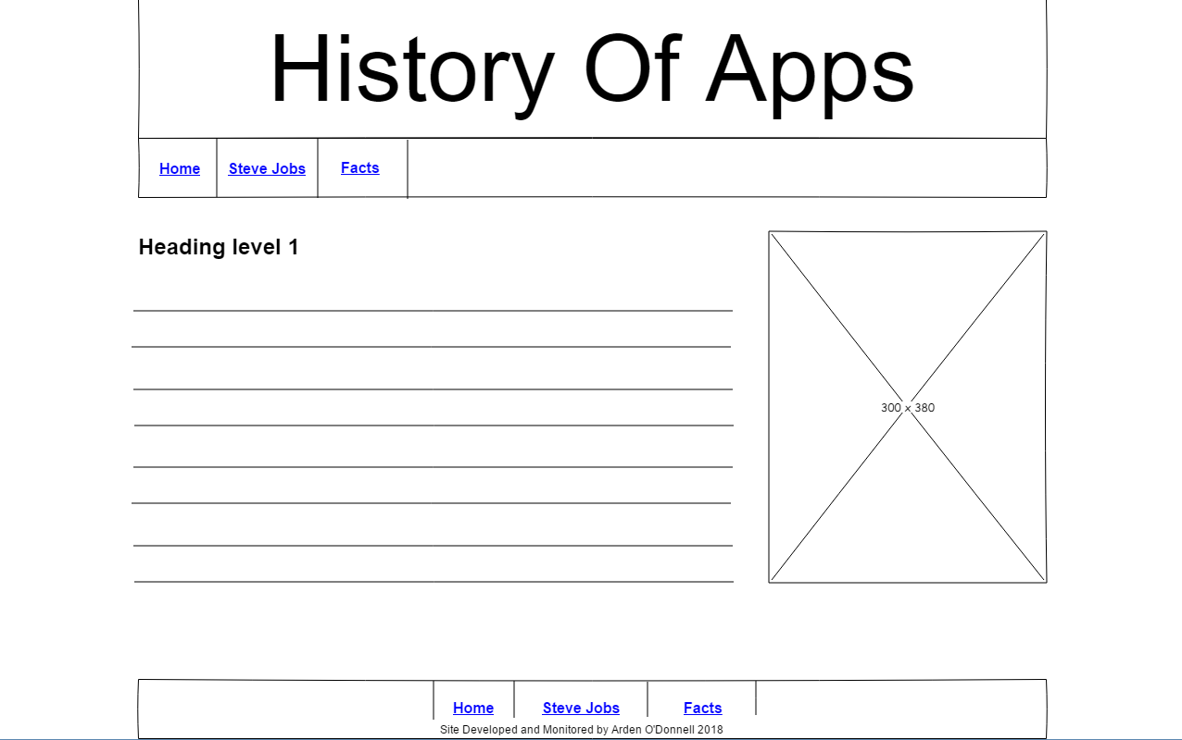

**Look at the images I have provided. Now source 3-4 copyright free images from here that you could use on your website:**

[**www.pixabay.com**](http://www.pixabay.com)

[**https://unsplash.com/**](https://unsplash.com/)

**Come up with 2-3 ideas for your colour palette (nav bar and footer). My advice is to pick a great image for your index page and then put it through:**

[**https://www.canva.com/colors/color-palette-generator/**](https://www.canva.com/colors/color-palette-generator/)

**Copy and paste the colour values into your portfolio. The current trend is to use a minimalist design with a bright nav bar**

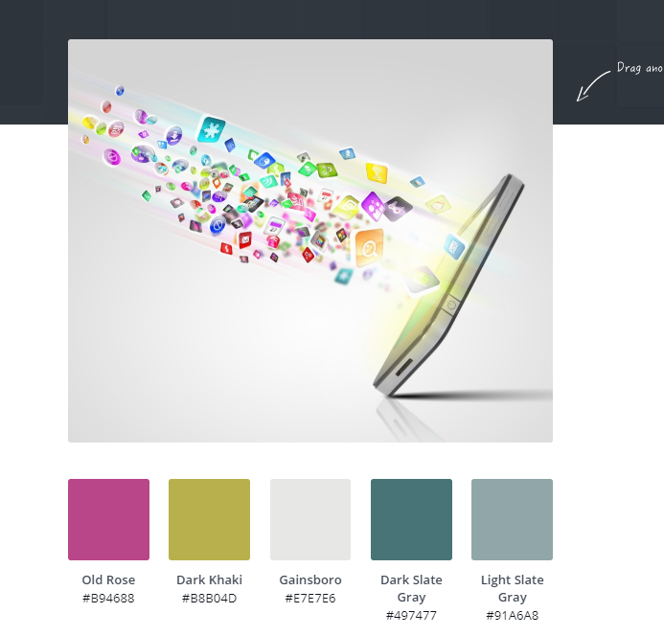

**Generate 2-3 font ideas :**

[**https://howtogetonline.com/best-google-font-combinations-currently-trending.php**](https://howtogetonline.com/best-google-font-combinations-currently-trending.php)

Copy and paste your proposed fonts into your portfolio

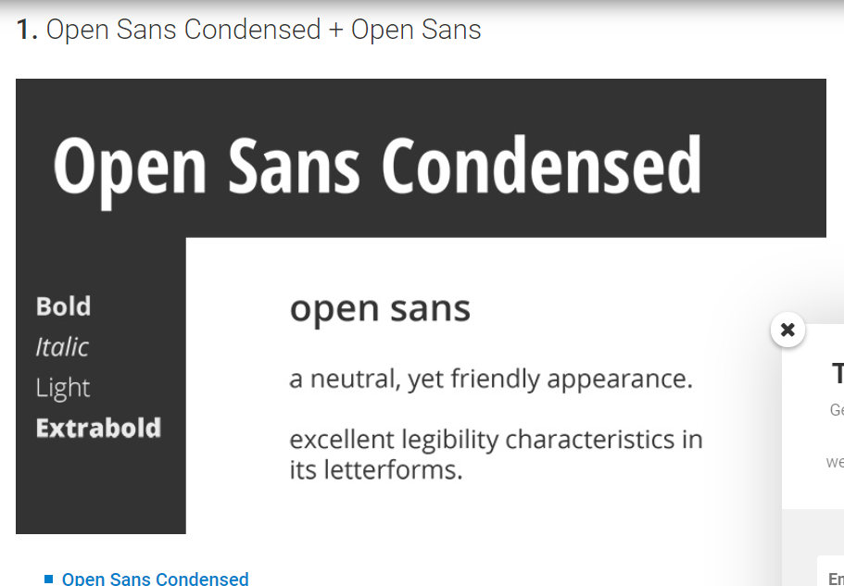

Image compression and naming your files correctly

* All images (jpegs are photographs should be approx. 200kb) and pngs (flat graphics should be approx. 100kb)
* Files should be named lowercase and with underscores **e.g 2019_nike_basketball_socks_black rather than jp34fsset3124.jpeg**
* Your website folder should be called images

**Design Thinking Step 4:**

**Prototyping (creating your site)**

Day 1 – Creating HTML and CSS pages

Setting up your website folder is CRUCIAL, if this step is not done correctly then your links will not be relative(which means they are all relative to the website folder you create) Mrs Bennett will walk you through this step, OR watch the video on the

**Rdrive/11DGT/1.4/Dreamweaver site set up**

Create a new folder called practice assessment within your practice assessment folder.

Day 2- Adding content to your index.html page

1. Look at the head tag on your index.html page, note that it contains all the information about your page that isn’t actually displayed on your page.
2. In the title tag- add the words: Top Apps 2019.
3. Click after the </head> tag and on a new line add a <header> tag.
4. Within the header tag you are going to add the follow image (banner) from your images folder. Drag and drop this from your images folder on the left hand side. Make sure to add alt and title tag descriptions. Make the width of the image 80%

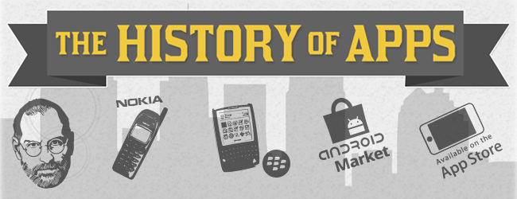

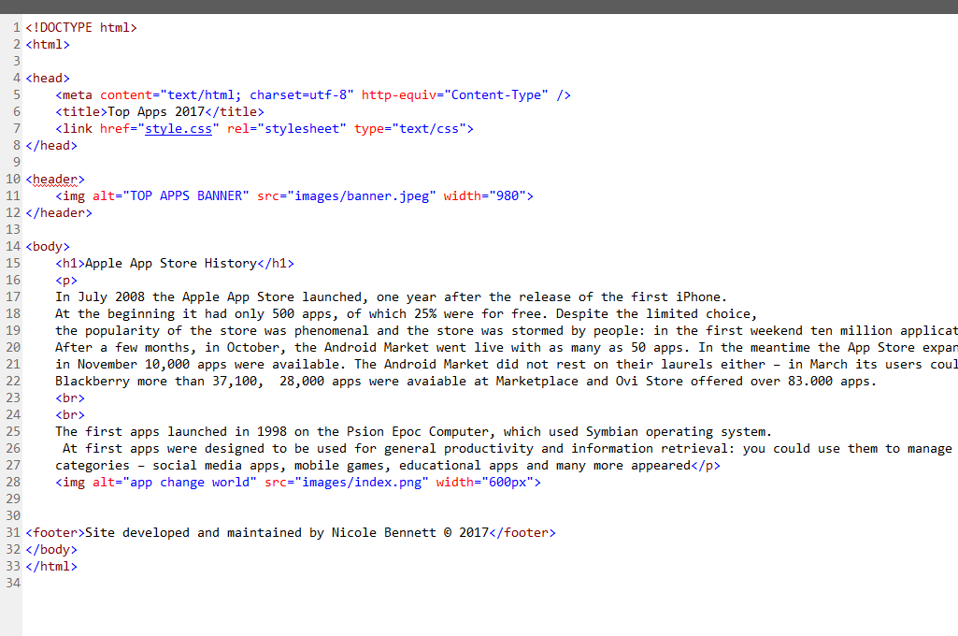

1. Now preview what your page looks like in a browser, press ctrl s to save your work. Then go to My Documents/11DGT/Web Design/Practice Website and double click on the index,html file and it should launch in a browser

It should look like (BLANK):

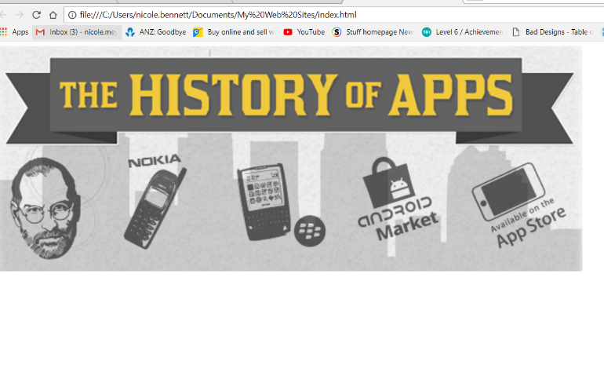

1. **Add the following code within your <body> tag to your index.html page.**

<h1>Apple App Store History</h1>

<br>

<p> In July 2008 the Apple App Store launched, one year after the release of the first iPhone. At the beginning it had only 500 apps, of which 25% were for free. Despite the limited choice, the popularity of the store was phenomenal and the store was stormed by people: in the first weekend ten million applications were downloaded.</p>

<p> After a few months, in October, the Android Market went live with as many as 50 apps. In the meantime the App Store expanded rapidly: in November 10,000 apps were available. The Android Market did not rest on their laurels either – in March its users could choose from 2,300 applications. On April 2009 Blackberry App World went live and in May Ovi store of Nokia launched. The Windows Phone Marketplace launched relatively late, comparing to other stores – in October 2010 becoming the fifth major distributor of mobile applications. <p>In July 2011 the Android Market had more than 250,000 thousands apps, Blackberry more than 37,100, 28,000 apps were avaiable at Marketplace and Ovi Store offered over 83.000 apps.</p>

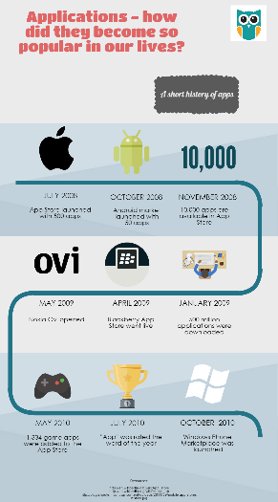<p>The first apps launched in 1998 on the Psion Epoc Computer, which used Symbian operating system. At first apps were designed to be used for general productivity and information retrieval: you could use them to manage your emails, calendar or access weather information. Due to high demand developers started creating apps in other categories – social media apps, mobile games, educational apps and many more appeared. </p>

Now add the following image index.png and set the width to 600px and height to something that makes the image not stretched.

**Your page should like this:**

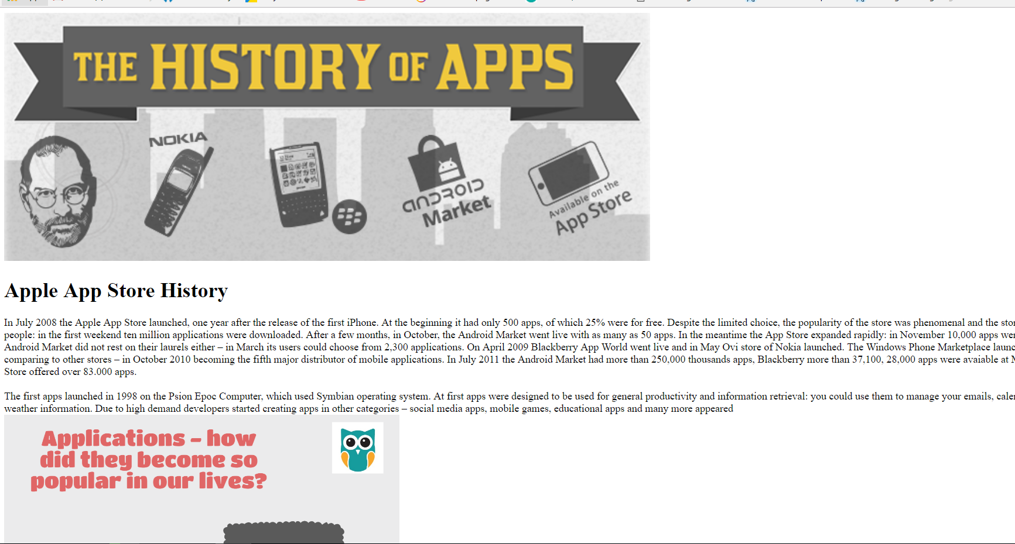

Add a footer tag,

this should sit outside of your body tag.

**<footer>Site developed and maintained by (your name) © 2019</footer>**

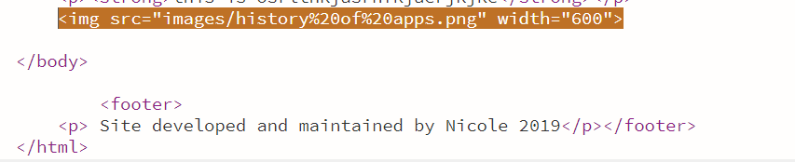

Adding style to your page using CSS

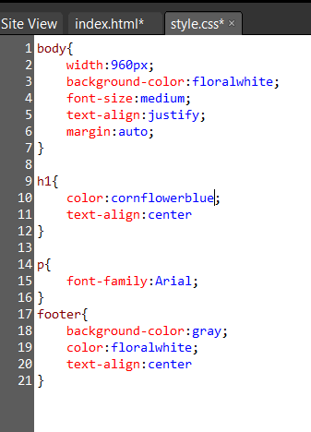

80%;

Click on the CSS page you created earlier, it should be totally blank. Cascading Style Sheets (CSS) is a style sheet language used for describing the look and formatting of a document written in a markup language.

The more CSS you add the better your page will look ☺.Add the following code to your css page and test your html in a browser to see the changes:

Day 2 - Importing fonts into your CSS

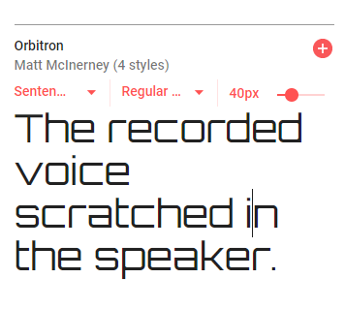**Visit the following site:** <https://fonts.google.com>

**Find two font combinations you like and that you placed in your portfolio. Pick a cursive font for you nav bar and as sans-serif font for your main content.**

Click on the red plus symbol., you may want to click on Regular and change the font wight to something bolder if you plan on using as your nav bar fonr.

**Click on the family selected black bar at the bottom of the browser**

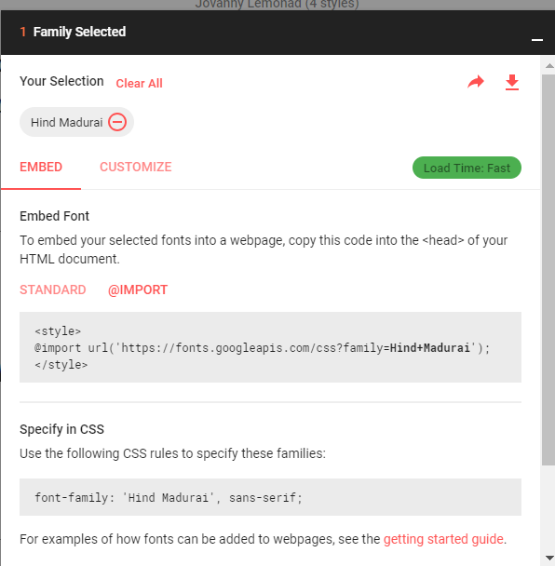

**To then place this in your CSS click on the @IMPORT and copy the link and copy and paste into the top line of your styles.css page like the example below:**

**Copy the font family to your body tag and the second font to your nav li a (that is your navigation bar and your footer)**

Creating your Steve Jobs page

1. **Copy the header tag / footer tags from your 1st page.**
2. **Copy and paste code and add the steve jobs image**

<h1>Steve Jobs</h1>

**<img alt="stevejobs" src="images/steve%20jobs.jpg" width="350px">**

<p>In the beginning, Steve was opposed to third-party apps, and wanted developers to create web apps that could be used through the device’s mobile Safari web browser. According to Apple board member, Art Levinson, “Jobs at first quashed the discussion” of allowing apps on the company’s debut smartphone. </p>

<p>However, web apps never really took off, and Steve changed his mind — announcing in October, 2007, that a software development kit for the iPhone would be available the following year. </p>

<p>In July, 2008, the App Store was born.

It is now one of the iPhone’s biggest selling points, with a recent advertising campaign that was based on the tagline, <strong> “There’s an app for that.” </strong></p>

<p>The App Store is now home to over 500,000 apps, and is the largest and most successful mobile application store available,

with over 18 billion downloads since it opened its doors.

</p>

<strong>Do you think the iPhone would be as successful as it is today without the birth of the App Store?</strong>

**Preview your page:**

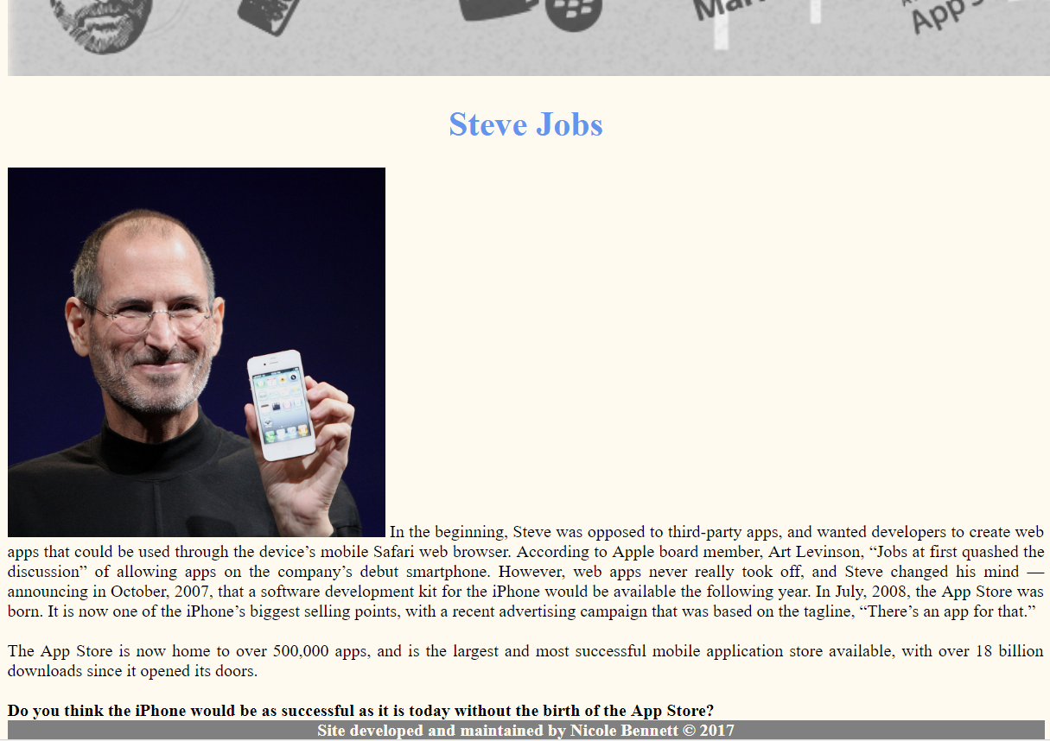

**Navigation bar - to connect your 2 pages together**

Add a nav tag like the code below. To create your links properly you need to open up the anchor tag and select the HTML page you want to link to. Change the text of the index page to “Home” rather than Top Apps 2019.

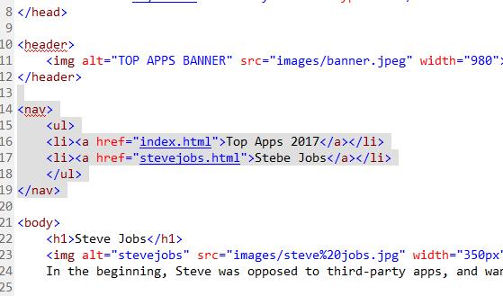

**Adding a class to float your image to the right**

Add the class to your image of Steve Jobs, we want to end up moving this image to right using CSS

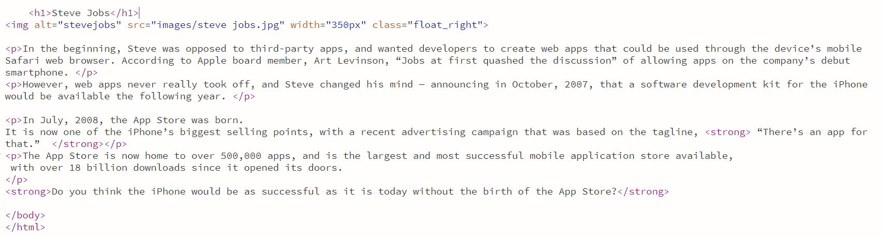

This located the class you assigned to the image and will then float it the right and html will just flow around it. KEY TIP: You can apply this class to any other image by just adding the class name to the image in your html

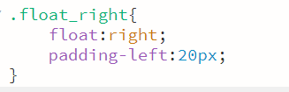

ADD THE ABOVE CODE TO STYLE.CSS

**Add the following code to your style.css page. This will style your nav bar to look like this:**

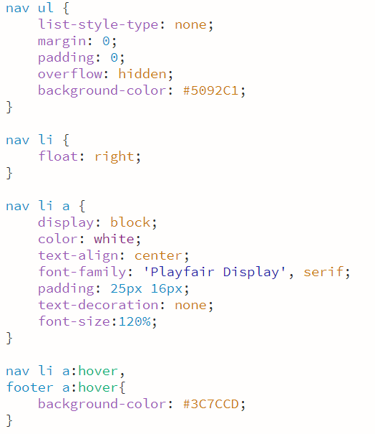

This is the hover effect for both your nav bar and footer. Change this to your second colour in your portfolio colour palette ideas.

This locates your nav tag, the list and the anchor tags within it. Displays the links in a block (line)

Put your chosen hex value from your portfolio here to make your nav bar the colour you want

Links are floated to the right of the page

This locates the nav tag, and the unordered list and removes the list style.

**Day 3- Adding hyperlinks to the footer**

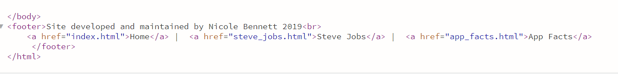

Add the following CSS code to your stylesheet

Styling your nav bar so it looks consistent with your nav bar in terms of background colour and font choice.

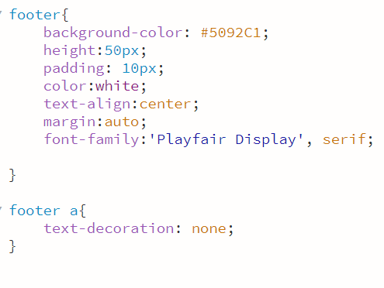

Removes the default underline from your hyperlink in your footer

**Adding content to apps_facts.html**

* Copy your nav tag which contains your links to your other pages.
* Copy and paste the footer.
* Make sure you stylesheet is attached. If not, File>Attach Stylesheet
* Using an ordered list, <ul><li></ul> <https://www.w3schools.com/html/html_lists.asp>

**Copy and paste this code into the body section of your app_facts.html page**

<h1>Top 10 Facts About Apps</h1>

Mobile apps are used more than websites. A common assumption is that mobile applications are used less compared to websites. However, people actually spend 87% of their time on mobile apps, making mobile app development a must for businesses.

Mobile apps can be developed on multiple platforms. Good app design in NZ is essential because there are different operating systems and different programming languages per platform. Developing mobile apps on multiple platforms is essential in gaining the widest potential audience and maximizing earning potential.

iOS is the platform most developers use first. 42% of developers choose iOS as a mobile app development platform, while 31% choose Android.

iOS is a superior competitor to Android. Across all competitive points except for cost and how easy it is to learn as a development platform, iOS has more advantage over Android.

Advertising is the most popular source of revenue for apps. In app advertising, revenue is expected to reach $16.9 billion dollars by 2018. 38% of mobile developers use ad revenue, while in-app purchases are used by 37% of developers as revenue.

63% of millennials preferred to make purchases on mobile apps. However, 21% of millennials would be turned off from a business they had a poor app experience with, and 31% would not recommend the business to others. Good mobile app design is important in establishing a good brand.

There are 5 million apps available to download. There’s a wide range of mobile applications available, with 2.2 million on Google Play, 2 million on the Apple App Store, and 0.7 million in Windows. Good app design in NZ is essential in making your application stand out. In fact,

The estimated number of app downloads in 2017 is 269 billion. This would be 33 apps for every person on the planet. Meanwhile, in 2016, there were 493 million app downloads per day. However, in developing mobile apps, one has to ensure that the app provides a great user experience and won’t be deleted immediately.

60% of Apple App Store apps have never been downloaded. Meanwhile, after less than 72 hours, more than 70% of downloaded apps are deleted.

Tablet sales are expected to match computer sales within the next two years. With mobile app development taking precedence over websites for functionality, there’s less need for personal computers and an increasing need for mobile devices like tablets and smartphones.

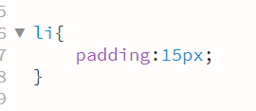

Add some style to your CCSS, this adds padding to each list element

Example of what your code should look like:

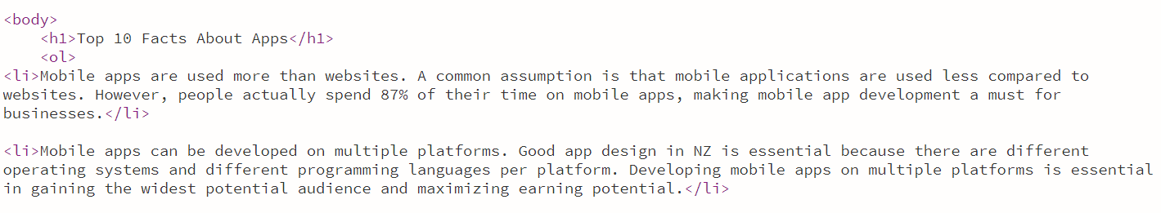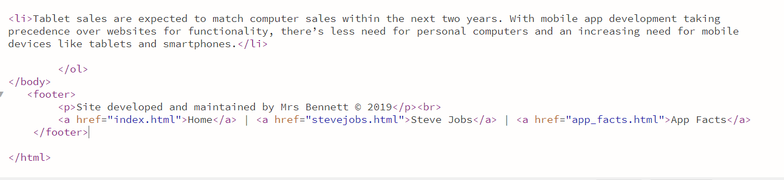

**Extension task – add one of the images your downloaded from pixabay and add it to this page to break up the large chunks of text. Add a class to it called class=”center_image” in your css write the following rule. This should center the image.**

**.center_image { margin-left:30%; margin-right:30%; }**

**Clean up your code**

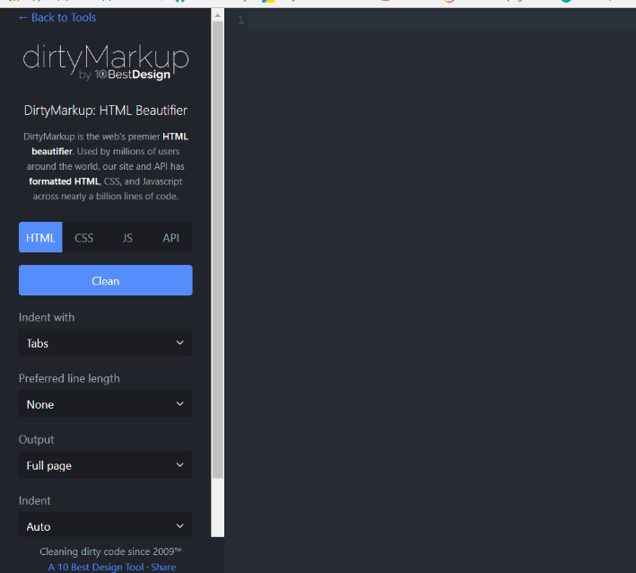**Clean up your code to make it easier to read and correctly laid out, use dirtymark.com**

Copy and paste each HTML page in and hit clean then cut and paste it back into your HTML file

**Opacity Effect on images**

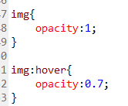

**Day 4 – Parallax effect**

MRS BENNETT TO SHOW YOU HOW – THIS IS AN EXTRA FOR MERIT/EXCCELLENCE STUDENTS

<https://www.w3schools.com/howto/howto_css_parallax.asp>

**Validate your HTML code - SUPER IMPORTANT**

This counts as testing evidence, copy and paste your code into here:

<https://validator.w3.org/#validate_by_input>

Your goal is to have zero errors in all three of your HTML pages.

<http://jigsaw.w3.org/css-validator/#validate_by_input> – CHECK YOUR CSS TOO.

**Screenshot your results and now go about fixing the errors 😊 An Excellence student will have zero errors in their code.**

**NEARLY FINISHED**

1. Add detailed Code Comments to all the different sections of your code explaining what your code is displaying <!-- -->
2. Add code comments to your CSS /*
3. Keep adding CSS to your page to make it look professional.

**Add a favicon to your site**

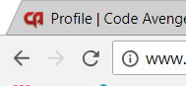

Here's an example of the code you can use. Place it inside the [<head>](http://www.html.am/tags/html-head-tag.cfm) element (replace the image location with the location of the image to be used): A favicon is normally 16px by 16px. Create a favicon using paint.net and save the file type as png.

<link rel="shortcut icon" href="http://example.com/favicon.png" />

**Add your logo to your nav bar**

Create a basic logo in paint.net – Top Apps 2019 and ad a phone. Remove the background so it is not white when insert it you will not have an ugly white background. Key tip – do not use black on a blue background the contrast will make it too hard to read!

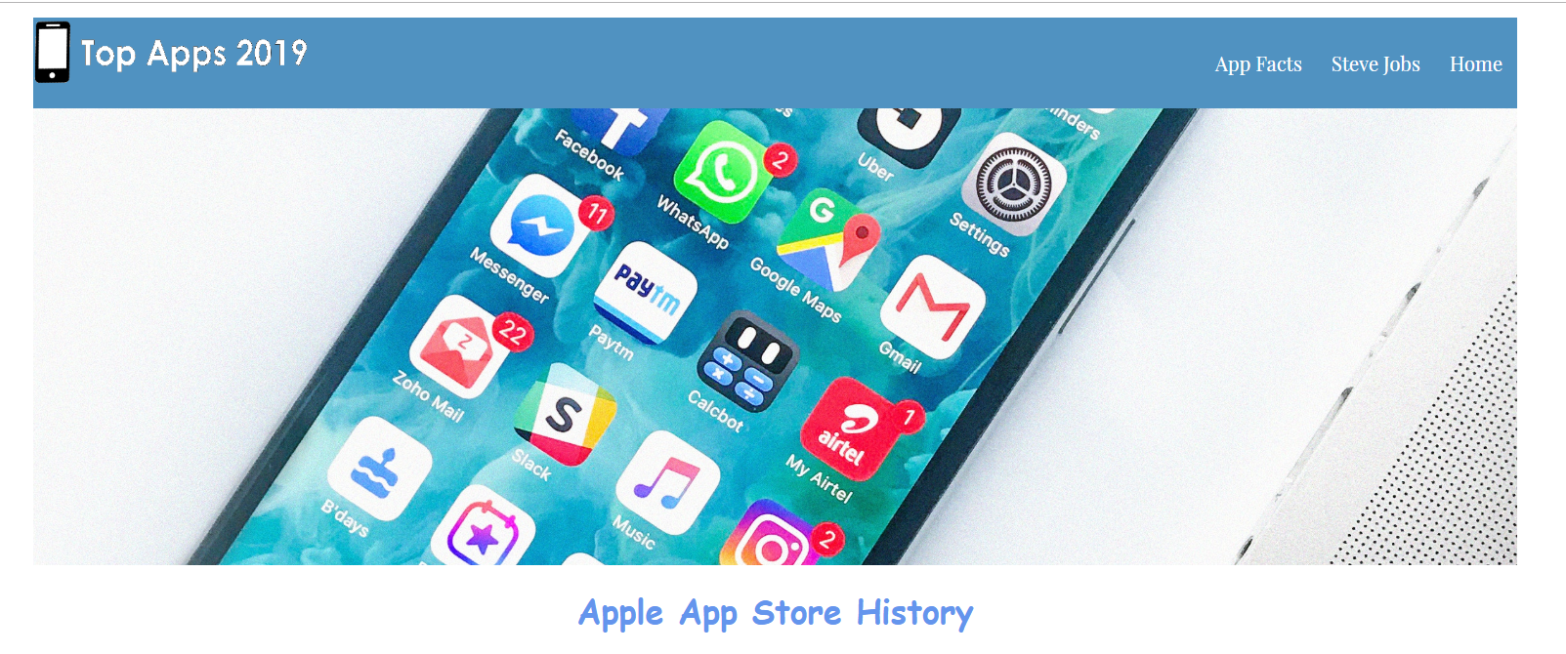

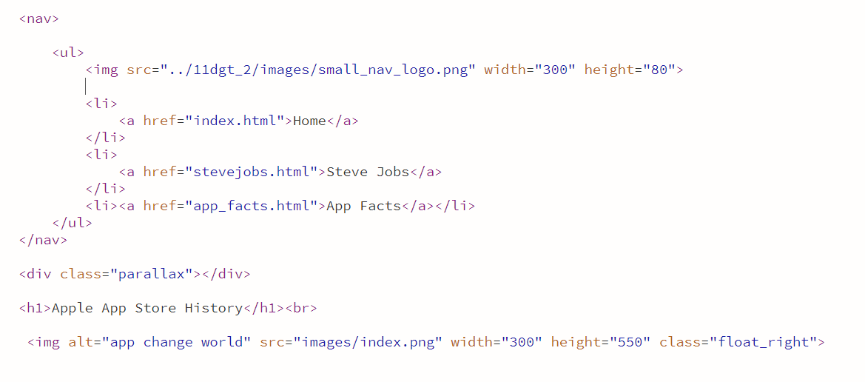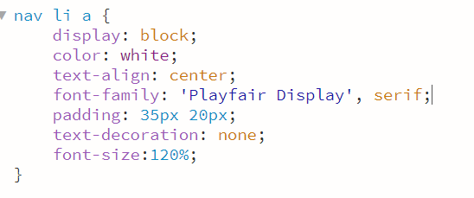

I have increased my top padding so that my hyperlinks have moved down a bit to make it more inline

**Add a class to your logo to add in some padding – this is evidence of refinement(Excellence)** 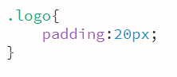



**Want to get Merit/ Excellence in your assessment**

You need to take screenshots of you testing your site with your end users and getting some feedback and then making some refinements. A refinement could be trialling different nav bar colours, fonts, hover effect etc. A hover effects can be increasing the size of the font, or adding text decoration etc. The choices are endless 😊

**Here are some examples of us refining our nav bar**

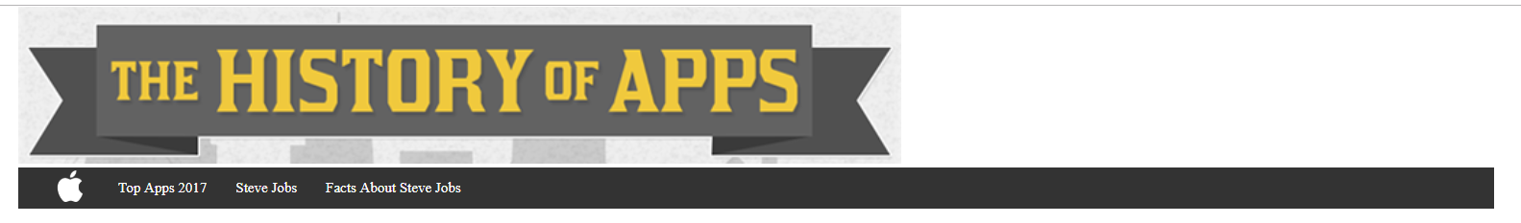

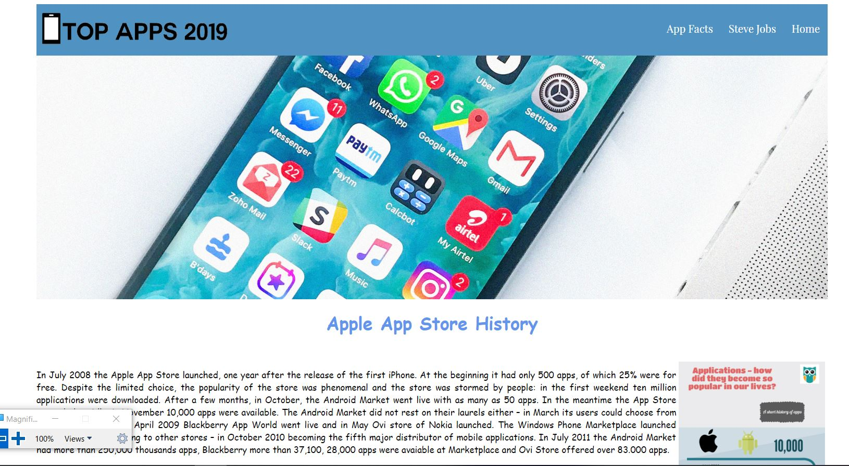

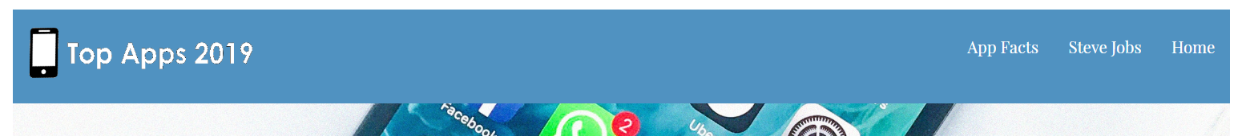

**Trialling new fonts and the order of my hyperlinks, found a new font for my nav bar, imported it to my CSS and then replaced it and got feedback**

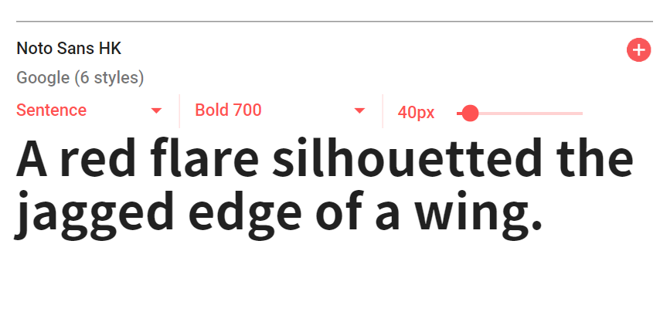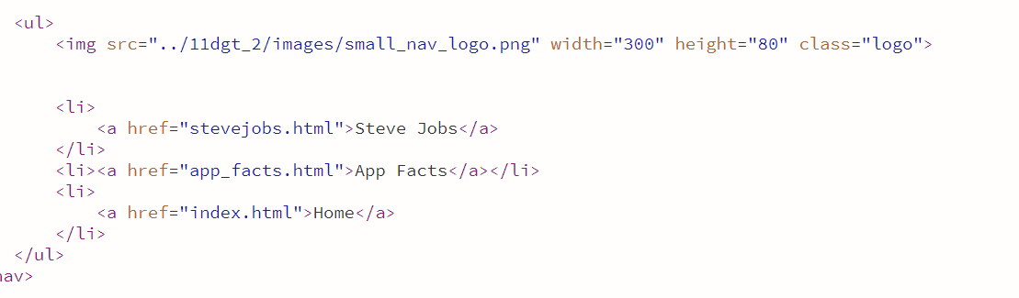



**I changed the colour of the logo as it was too similar to the nav bar, could be confusing for users, after trialling a couple of ideas I have made another change!**





**I STILL DON’T LIKE THAT BLUE! So I look at my parallax image and research the Instagram colours**

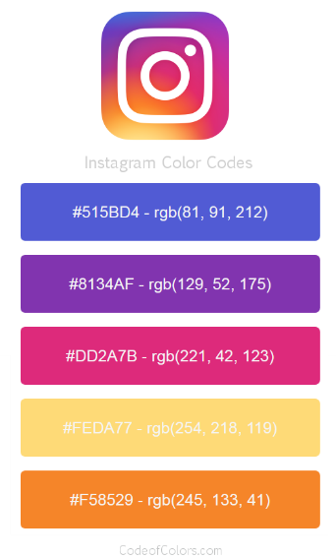



**this is what iterative design looks like! The orange really pops and the white gives the best contrast, increasing the usability of it.**

**Floating your image to the centre, looks better than cramped up on the left! Makes it easier to read**

Before After

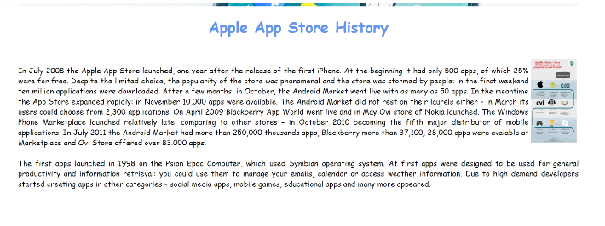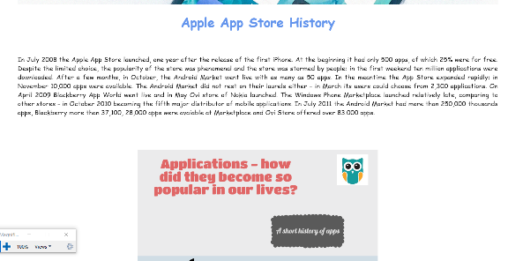

**Add another class to your CSS, keep your float right class as**

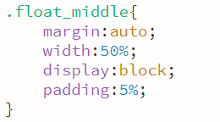**that is controlling steve jobs image, and move it in your html to break up the paragraph text.**

**Other cool things you can learn and add to your site:**

<https://www.w3schools.com/css/tryit.asp?filename=trycss_inline-block_nav>

<https://www.w3schools.com/css/css3_borders.asp>

<https://www.w3schools.com/css/css3_shadows.asp>